RC tutorial 003 - Creating your own alignment geometry
===================================================
Revised 2022-10-23
- This tutorial's goal is to teach you about clothoids in RailCOMPLETE tracks.
- Assumed RailCOMPLETE skills: Previous lessons.
- Assumed railway skills: You know about railway geometry - lines, arcs and spirals (clothoids) in the XY plane.
- Time to spend here: 1 hour.
- Suggested reading: “2021-05-23_001 EN Introduction to RailCOMPLETE v2021.0”, which can be downloaded from our web pages.
- Notice to users with non-English versions of AutoCAD – see footnote.
- This example was prepared using software release 2022.2.0.7 with Norwegian DNA version “NO-BN 2021.a”,” 2021-11-27T21:11:27+01:00;2021.a”.

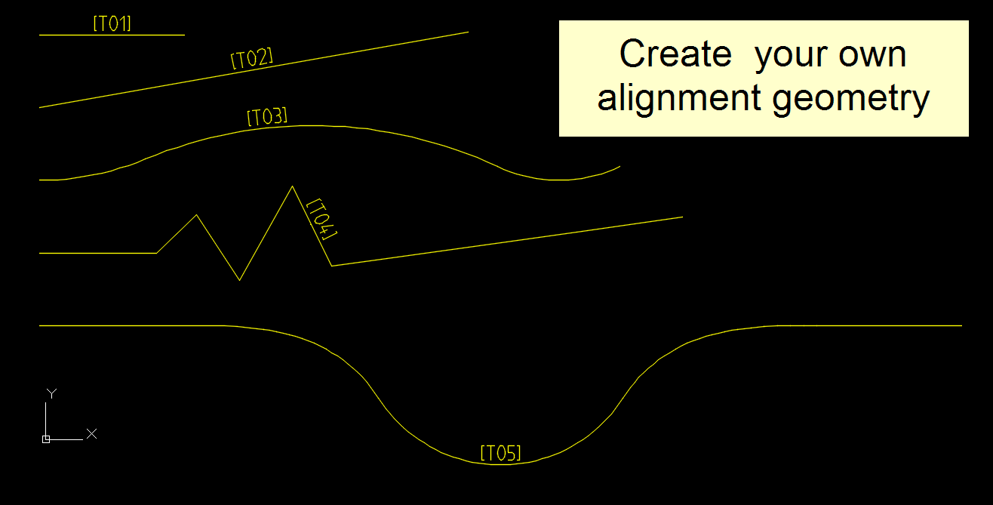
- Start AutoCAD with RailCOMPLETE, then open the ‘National Tutorials’ folder and locate the DWG file named after this tutorial. You can either type RC-OpenNationalTutorialsFolder or you can locate the button below the RC logo in the upper left corner of your AutoCAD window.
- Activate the RC-ShowGeometry tool to see your changes directly in modelspace while you make modifications to the alignment, and the alignent is selected.
- T01 - Straightline track
a- Use F8 to activate the AutoCAD Ortho drawing mode
b- Start RC-CreateAlignment with a railway track as object type (JBTKO_SPO “Spor”, then click where you want pos 0 to start
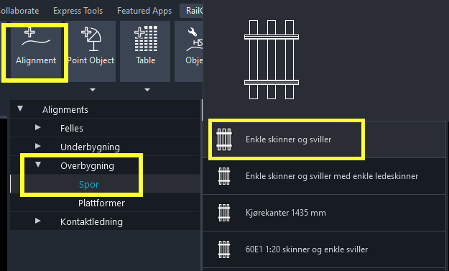
c- The function always starts in LINE mode. You can see the other available modes (CURVE and SPIRAL) by pressing the 'Down' key.
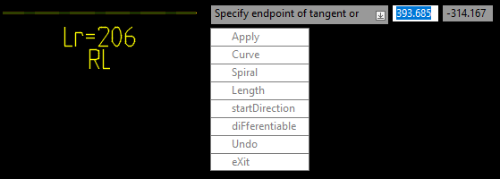
d- Enter 'L' (Length) and enter '90'. A preview is shown of a railway track being straight and 90 m long.
e- Note that you can at any time use Ctrl+Z to undo your last segment.
f- Re-enter 'L' and enter this time '70'. The preview changes to a 70 m long track.
g- Repeat again, enter 'L' and '100'. The preview shows a 100 m long track. Accept this segment by left-clicking once.
h- Then finish the alignment by RIGHT-clicking, and give it value 'T01' for its property @code
i- Start the RC-ManageProperties (the Property Manager) and check the alignment's code ('T01') and RcType (object type), ' JBTKO_SPO Spor’. The ‘Variant’ property can be changed to give the track another appearance in 3D. None of the track’s mathematical definition, the socalled ‘alignment’ data, will change if you change the Variant. The ‘code’ property can be changed to give the alignment another name. The ‘name’ property is just a more elaborate or more human-readable version of the code.
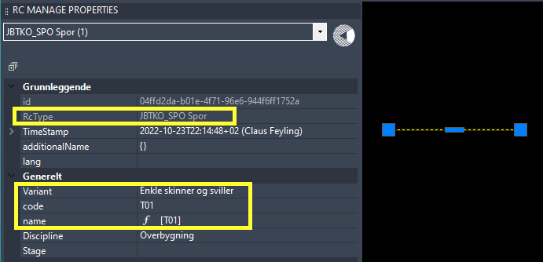
j- Activate RC-ShowAlignmentName to see the track's name, when selected. You may have to zoom in/out to see it, because the text size snaps to predefined text heights when you zoom.
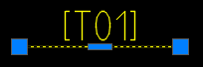
k- Save your work as DWG (QSAVE or CLOSE or SAVE or SAVEAS).
l- Save your work in LandXML format as well, for exhange with other railway softwares, using RC-ExportLandXmlAlignments.
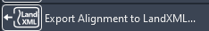
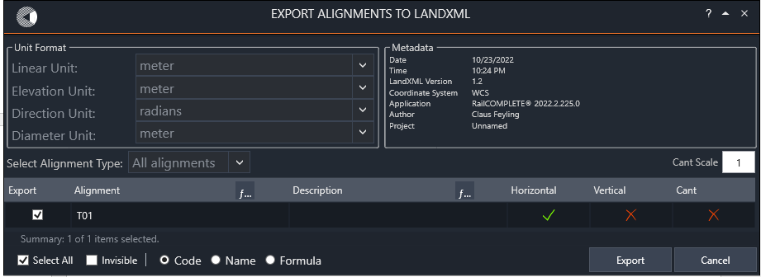
m- Open a virgin DWG file, start it as a RailCOMPLETE document, and use RC-ImportLandXmlAlignments to reimport your tracks. Make sure that you set the object type and variant before you press the Import button.
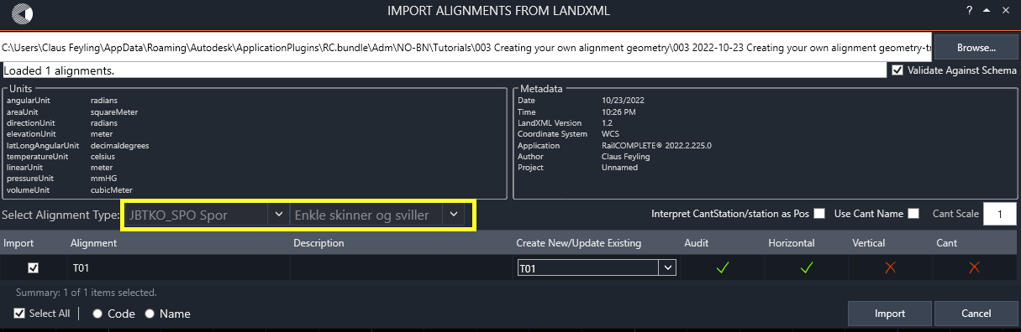

- T02 - Straight 300m long track, drawn at a given angle in the XY-plane
a- Toggle off ortho mode (F8), then start RC-CreateAlignment with a railway track type ('spor')
b- Set the start direction using the Down key and selection "startDirection" or press D then ENTER. Then point out the direction by clicking twice in modelspace, or enter the angle 15 in decimal degrees.
c- Set the Length to 300, then end that segment with left-click or ‘A’ (apply) and finish the alignment with right-click, call it 'T02'. Note that you may as well start with L 300 and then do D 15, then A and finally ENTER.
d- In the Alignment Manager, check the 'Bind to Selection' box at your lower left. This has the effect that whenever you select an alignment in modelspace, it will also be marked in the Alignment Manager, and vice versa.
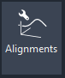 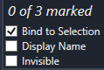
- T03 - Curved multi-segment track
a- Start drawing a railway track ('spor') along the X-axis: Set the initial drawing direction to zero degrees (which is East when you are in WCS Global coordinate system), then use ‘C’ to switch to Curve drawing mode, set Radius to 190 and Length to 75. Left-click pr press ‘A’ to apply this first segment.
b- Then move your cursor to point out a continued curve, press R and change radius to -300, set Length to 250 and left-click. You will see a right-curving arc.
c- Continue drawing a radius 100 (CCW) curve, set enddirectioN ('N') to 25 degrees, then apply.
d- Finish with right-click or ENTER and call it 'T03'.
- T04 - Straight track consisting of several zig-zag segments
- Start drawing a straight (tangent) railway track ('spor'), apply the first segment, then try to change drawing direction – it is not possible. Move your CAD cursor and left-click a few times - you will see that each new segment has the same direction as the previous.
b- Then press F (for 'diFferentiable') and select 0 (=false). You are now in a mode where each new segment may continue in a different direction.
c- Left click a few times and you'll see a zig-zagged line. Press ENTER or right-click or press ‘X’ for ‘eXit’, then name it ‘T04’.

- T05 - Straight line, clothoid and circular curve
a- Start out with drawing a 100 m straight line segment ('Tangent') along the positive X-axis direction, accept it with left-click or ‘A’. Enable ortho mode (F8) before you start, but remember to disable ortho mode again (F8) once you want to draw the curved segments.
b- Then switch to Spiral mode (clothoids), set the clothoid parameter using the ‘P’ selection. Enter ‘100’ as the value for A = sqrt(R*L) and set the clothoid’s length to L = 100, don’t apply yet.
c- The end radius’ absolute value automatically ends up with R = A*A/L = 100
d- Move your cursor down until you see a CW clothoid (negative rotation), then apply.
e- Then switch to Curve mode and set Length to 50, left-click to accept a CW curve (radius is still
-100)
f- Continue directly into a CCW curve of radius +100 for 200 meters, left-click to apply,
g- Then make a 50 m long CW curve with radius -100, apply
g- Switch back to Spiral mode and set ‘E’ (Endradius) to 0 (meaning 'Infinity', i.e. tangent line), apply.
h- Continue in Tangent line mode (diFferentiable mode), set length to 100m apply,
i.- Then finish the alignment with right-click or ‘X’ or ENTER, call it 'T05'.

Please check our website www.railcomplete.com for updates.
Corrections and suggestions are welcome to support@railcomplete.com.
Thank you for using RC Tutorials!

Your AutoCAD session has probably been started from a Windows shortcut of the type: “C:\Program Files\Autodesk\AutoCAD 2022\acad.exe” /product ACAD /language “fr-FR”, where “fr-FR” means “French language, France’s version”, or similar, or no language specified (English is the native language for AutoCAD). Native AutoCAD commands may have different names in your language pack, other than the COPY, COPYBASE, FIND etc that you see in our tutorial texts. In order to instruct AutoCAD to accept the native English command name, precede the native (English) command name by an underscore character, ‘_’. For instance: ‘_FIND’ will start AutoCAD’s native ‘FIND’ command even if you are using AutoCAD with the French language pack, where the command in French is called ‘RECHERCHER’. If a command needs an argument ‘ON’, and the French menu says ‘Allumer’, then you can enter ‘_ON’ to instruct AutoCAD to use the option’s native name. Furthermore, the English AutoCAD object selection prompt (command _SELECT) accepts many keyboard shortcuts such as A = (add) add to selection set, R = (remove) remove from selection set and AL = (all) all objects (and many more). These shortcuts are named differently in other language packs. In French they are for instance A=ajouter, S=supprimer, TO=tout. Consult AutoCAD Help in your native language.

